13.24: a) From Eq. (13.23),

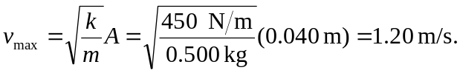

b) From Eq. (13.22),
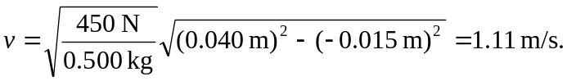
c) The extremes of acceleration occur at the extremes of motion, when 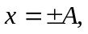 and
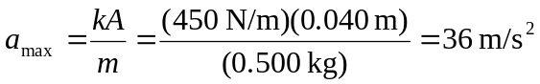
d) From Eq. (13.4), 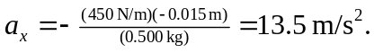
e) From Eq. (13.31), 